Introduction
Mantis is a free, open-source web application in which you can log, track, and mark issues resolved.

Logging In
Accounts have already been established for you in Mantis. To login, visit https://mantis.luc.edu/ and type in your UVID and password. Click the Login button.

Homepage
You will now be directed to a dashboard page, called My View, listing all of the issues that you have reported and modified, and also all of the issues that are assigned to you.

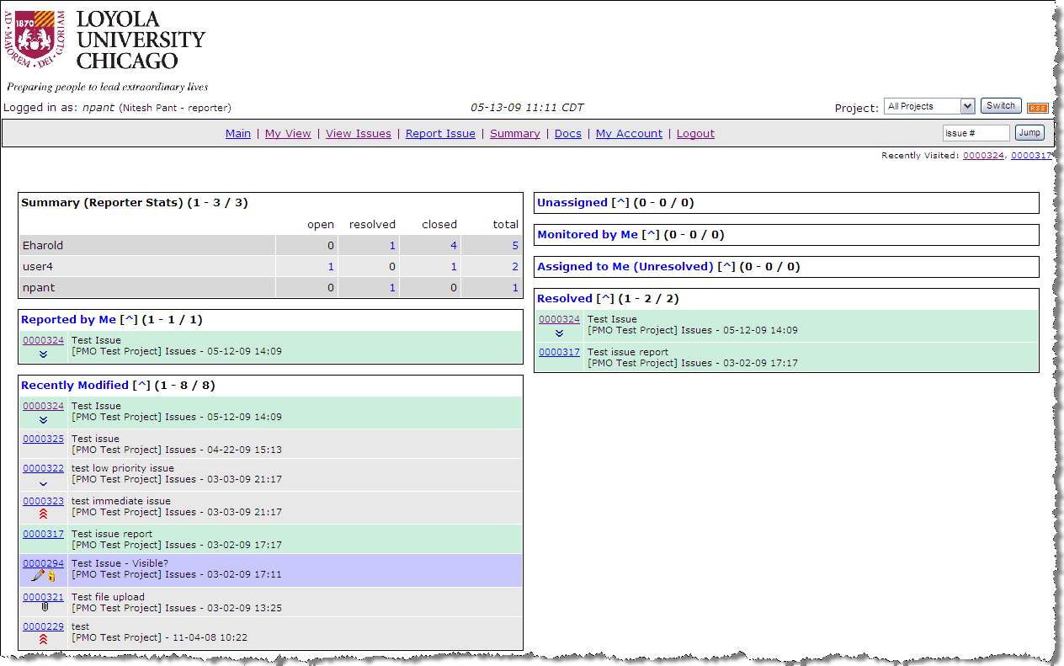

Project Selection
The life cycle of an issue starts with its creation. First, in the upper right hand corner, make sure you have selected the project you want to work on. Select the desired project and click the ‘Switch’ button.

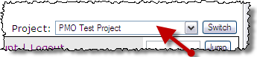
Reporting an Issue
Once this project is selected click on the “Report Issue” link.
Next fill out the issue form and populate all required fields. Assigning the issue to an individual will assign them the responsibility to take action on the issue. Click “Submit Report” when you are finished in order to create the issue.
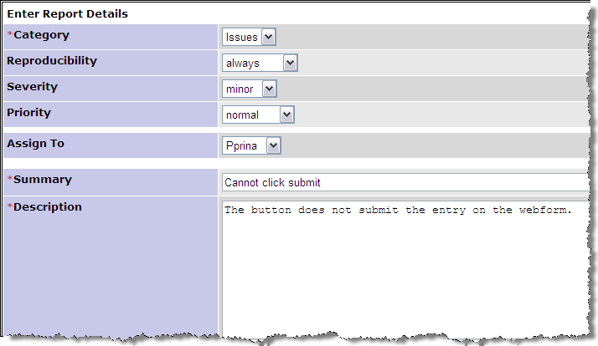

Once an issue is assigned an email will be sent to the owner of the task. Any updates to the issue will be emailed to you.

Modifying and Resolving an Issue

When viewing an issue’s detail screen, click the ‘Update Issue’ button to modify. When notes are added the status of the issue will be changed to ‘Feedback’. When the developer feels the issue is fixed, the status should be changed to ‘Resolved’ and change the resolution to ‘Fixed’. The issue can then be marked as ‘Closed’ by the manager of the Mantis project.
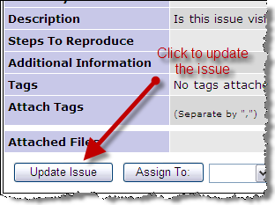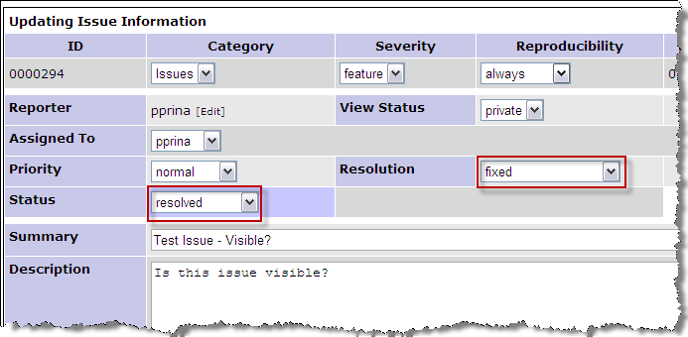

Status Workflow
Reporter
Mantis Project Manager
Mantis Project Manager
Issue Owner
Issue Owner

